**Project Design Phase - I**

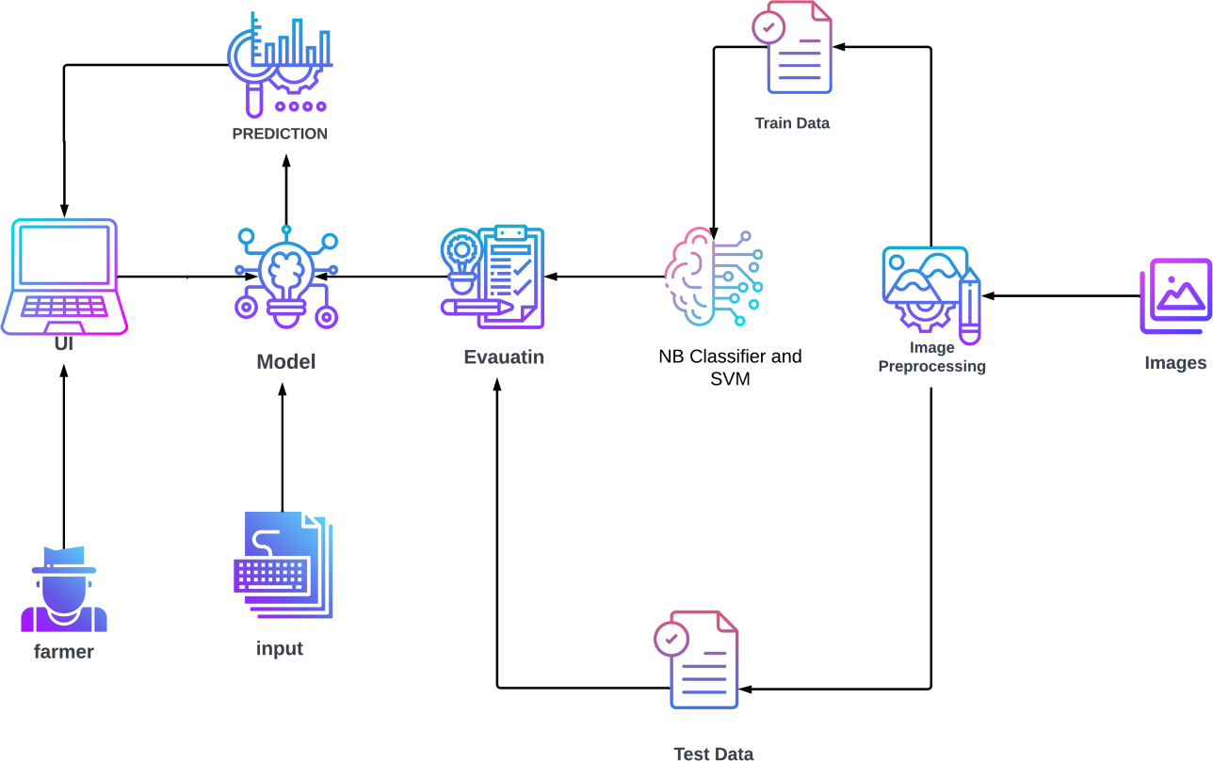

|  |  |
| --- | --- |
| **Assignment Date** | **17 October 2022** |
| **Team ID** | **PNT2022TMID19217** |
| **Project Name** | **Fertilizers Recommendation System for Diseased Crops** |
| **Maximum Marks** | **4 Marks** |

Crop disease in plants is predicted and suitable fertilizer is recommended for better yield. The images of the diseased plants are obtained and it is preprocessed against the dataset of diseased plants. Deep Learning Algorithm is used to process the images and then it is evaluated. Then a model is built on the evaluations, it is then trained using no. of. inputs and predictions are given to the users which subsequently helps in recommending the fertilizers.

The Convolutional layers are used to classify and process the images and further helps in recommending the fertilizers. The image classification steps are:

Image acquisition Preprocessing Segmentation Disease Prediction

Fertilizer Recommendation

**Solution Architecture**